Microsoft Azure - Starter Kits for Partners

Hands on Lab

Application Servers Scenario

With HA & Auto Scaling

Last Update: September 2015





**MICROSOFT MAKES NO WARRANTIES, EXPRESS, IMPLIED OR STATUTORY, AS TO THE INFORMATION IN THIS DOCUMENT.**

The information contained in this document represents the current view of Microsoft Corporation on the issues discussed as of the date of publication. Because Microsoft must respond to changing market conditions, it should not be interpreted to be a commitment on the part of Microsoft, and Microsoft cannot guarantee the accuracy of any information presented after the date of publication.

Complying with all applicable copyright laws is the responsibility of the user. Without limiting the rights under copyright, no part of this document may be reproduced, stored in or introduced into a retrieval system, or transmitted in any form or by any means (electronic, mechanical, photocopying, recording, or otherwise), or for any purpose, without the express written permission of Microsoft Corporation.

Microsoft may have patents, patent applications, trademarks, copyrights, or other intellectual property rights covering subject matter in this document. Except as expressly provided in any written license agreement from Microsoft, the furnishing of this document does not give you any license to these patents, trademarks, copyrights, or other intellectual property.

The descriptions of other companies’ products in this document, if any, are provided only as a convenience to you. Any such references should not be considered an endorsement or support by Microsoft. Microsoft cannot guarantee their accuracy, and the products may change over time. Also, the descriptions are intended as brief highlights to aid understanding, rather than as thorough coverage. For authoritative descriptions of these products, please consult their respective manufacturers.

© 2015 Microsoft Corporation. All rights reserved. Any use or distribution of these materials without express authorization of Microsoft Corp. is strictly prohibited.

Microsoft and Windows are either registered trademarks of Microsoft Corporation in the United States and/or other countries.

The names of actual companies and products mentioned herein may be the trademarks of their respective owners.

Contents

Overview 4

Objectives 4

Prerequisites 4

Exercises 5

Infrastructure Provisioning 5

Exercise 1: Creating the Virtual Network 5

Exercise 2: Creating the Storage Account 5

Exercise 3: Creating the PHP Farm 5

Exercise 4: Creating the MySQL Cluster 5

Exercise 5: Enabling Auto Scaling 5

Summary 5

## Overview

Using Microsoft Azure, as your Infrastructure as a Service (IaaS) platform, will enable you to create and manage your infrastructure quickly, provisioning and accessing any host ubiquitously. Grow your business through the cloud-based infrastructure, reducing the costs of licensing, provisioning and backup.

In this hands-on Lab, you will learn how to deploy a simple PHP application to a Web Farm hosted in Microsoft Azure IaaS, using MySQL and configuring load balancing/auto scaling.

**Estimated time** to complete this lab: **180 minutes**.

**Audience**: IT Pro, Architect, Application Owners and Developers

### Objectives

In this hands-on lab, you will learn how to:

* Create a Virtual Network with and Subnets
* Create a Web Farm (PHP) using Microsoft Azure Management Portal
* Create Virtual Machines for MYSQL
* Configure Auto Scaling

The Hands On covers the following Architecture:

### Prerequisites

The following is required to complete this hands-on lab:

* A Microsoft Azure subscription - [sign up for a free trial](http://aka.ms/WATK-FreeTrial)
* [Azure PowerShell 0.7.4](http://go.microsoft.com/fwlink/p/?linkid=320376)  or higher
* [Windows PowerShell 3.0](http://go.microsoft.com/fwlink/p/?LinkId=393708) or higher

## Exercises

## Infrastructure Provisioning

### Exercise 1: Creating the Virtual Network

In this exercise, you will learn how to create a Virtual Network in Microsoft Azure.

#### Task 1 – Create Virtual Network

In this task, you will create a Cloud-Only Virtual Network in the Management Portal. When you create a virtual network, your services and VMs within the VNet can communicate securely with each other without having to go out through the Internet. Creating a dedicated cloud-only virtual network is a relatively fast and easy process. Because a cloud-only virtual network isn’t intended for cross-premises connectivity, you won’t need to acquire and configure a VPN device or authentication certificates.

1. Log in to the **Microsoft Azure Management Portal**.
2. In the lower left-hand corner of the screen, click **New**. In the navigation pane, click **Network Services**, and then click **Virtual Network**. Click **Custom Create** to begin the configuration wizard.
3. On the **Virtual Network Details** page, enter the information below:

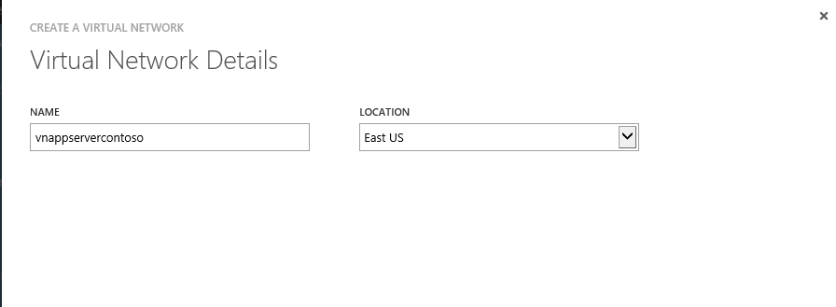

1. On the **DNS Servers and VPN Connectivity** page, don’t make any changes. Just move forward to the next page by clicking the arrow. By default, Azure provides basic name resolution for your virtual network. It’s possible that your name resolution requirements are more complex than can be handled by the basic Azure name resolution. In that case, you may later want to add a virtual machine running DNS to your virtual network.
2. The **Virtual Network Address Spaces** page is where you enter the address space that you want to use for this VNet.
3. Create the following subnets:

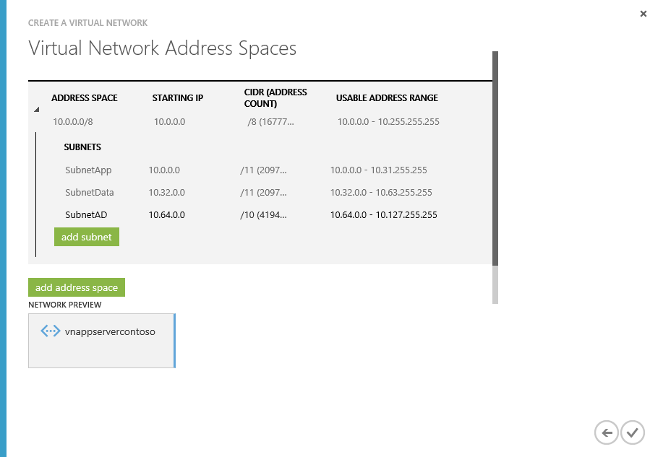

1. Click the checkmark on the lower right of the Virtual Network Address Spaces page and your virtual network will begin to create. When your virtual network has been created, you will see **Created** listed under **Status** on the **networks** page in the Management Portal.

### Exercise 2: Creating the Storage Account

* 1. In this exercise, you will learn how to create a Storage Account.

1. Log in to the **Microsoft Azure Management Portal**.
2. Click Create New, click Storage, and then click Quick Create.
3. In URL, enter a subdomain name to use in the storage account URL.
4. In Region, select a region for the storage. For this exercise select the previously created.
5. If you have more than one Azure subscription, then the Subscription field is displayed. In Subscription, enter the Azure subscription that you want to use the storage account with. You can create up to five storage accounts for a subscription.
6. In Replication, select the level of replication that you desire for your storage account. For this exercise, select Locally Redundant. *Locally redundant storage (LRS)* maintains three copies of your data. LRS is replicated three times within a single facility in a single region.
7. Your storage account should be similar to:
   1. 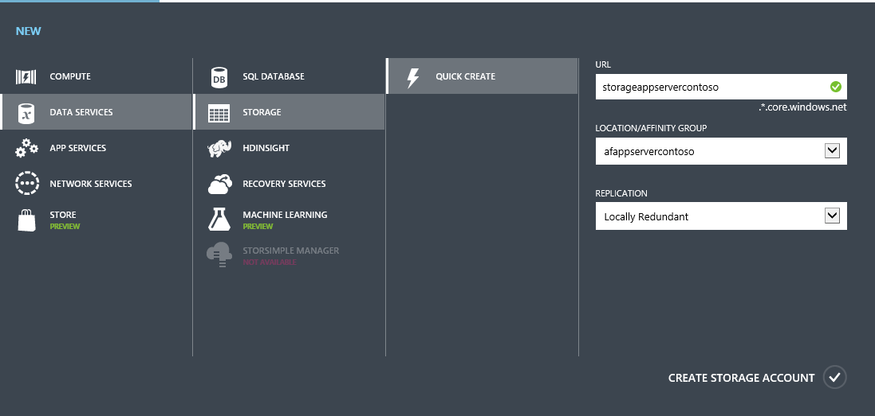

### Exercise 3: Creating the PHP Farm

1. Follow the Scott Hanselmans article, where he outlines How to setup a Load Balanced Web Farm of Virtual Machines Linux on Microsoft Azure (with command line)
2. Note: Make sure your use the VNET and storage account created in the previous steps.
3. **Scenario**: <http://www.hanselman.com/blog/HowToSetupALoadBalancedWebFarmOfVirtualMachinesLinuxOrOtherwiseOnWindowsAzureCommandLine.aspx>

### Exercise 4: Creating the MySQL Cluster

Follow the following article, where we outline a shared-nothing two-node single-master MySQL high availability solution based on DRBD, Corosync and Pacemaker. Only one node is running MySQL at a time. Reading and writing from the DRBD resource is also limited to only one node at a time.

The purpose of this article is to explore and illustrate the different approaches available to deploy highly available Linux-based services on Microsoft Azure, exploring MySQL Server high availability as a primer. A video illustrating this approach is available on [Channel 9](http://channel9.msdn.com/Blogs/Open/Load-balancing-highly-available-Linux-services-on-Windows-Azure-OpenLDAP-and-MySQL).

Note: Make sure your use the VNET and storage account created in the previous steps.

**Scenario**: <https://azure.microsoft.com/en-in/documentation/articles/virtual-machines-linux-mysql-cluster/>

### Exercise 5: Enabling Auto Scaling

* On the Scale page of the Azure Management Portal, you can manually scale your application or you can set parameters to automatically scale it. You can scale applications that are running Web Roles, Worker Roles, or Virtual Machines. To scale an application that is running instances of Web Roles or Worker Roles, you add or remove role instances to accommodate the work load.
* The Virtual Machines that you add can be initially turned on or turned off, but they will be turned on in a scale-up action and turned off in a scale-down action.
* You can only scale an application within the **limit of cores for your subscription**. For example, if your subscription has a limit of twenty cores and you run an application with two medium sized Virtual Machines (a total of four cores), you can only scale up other cloud service deployments in your subscription by sixteen cores. **All Virtual Machines in an availability** **set** that are used in **scaling an application must be the same size**.

On the Scale page, you can configure your cloud service to automatically increase or decrease the number of instances or Virtual Machines that are used by your application. You can configure scaling based on the following parameters:

* [Average CPU usage](http://azure.microsoft.com/en-us/documentation/articles/cloud-services-how-to-scale/#averagecpu) - If the average percentage of CPU usage goes above or below specified thresholds, role instances are created or deleted, or Virtual Machines are are turned on or turned off from an availability set.
* [Queue messages](http://azure.microsoft.com/en-us/documentation/articles/cloud-services-how-to-scale/#queuemessages) - If the number of messages in a queue goes above or below a specified threshold, role instances are created or deleted, or Virtual Machines are are turned on or turned off from an availability set.

#### Task – Auto Scaling by CPU usage

1. In the [Management Portal](https://manage.windowsazure.com/), click **Cloud Services**, and then click the name of the cloud service to open the dashboard.
2. Click **Scale**.
3. Scroll to the section for the role or availability set, and then click **CPU**. This enables automatic scaling of your application based on the average percentage of CPU resources that it uses.

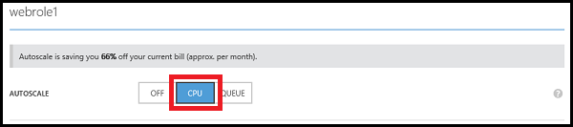

1. Each role or availability set has a slider for changing the number of instances that can be used. To set the maximum number of instances that can be used, drag the bar on the right to the right. To set the minimum number of instances that can be used, drag the bar on the left to the left.

**Note:** On the Scale page, **Instance** represents either a role instance or an instance of a Virtual Machine.

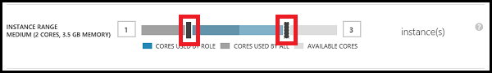

The maximum number of instances is limited by the cores that are available in the subscription. The colors of the slider represent the used and available cores in your subscription:

* Blue represents the maximum number of cores that the role can use.
* Dark grey represents the cores that are used by all roles and Virtual Machines in the subscription. When this value overlaps the cores used by the role, the color turns to dark blue.
* Light grey represents the cores that are available to use for scaling.
* Pink represents a change has been made that has not been saved.

1. A slider is used for specifying the range of average percentage of CPU usage. When the average percentage of CPU usage goes above the maximum setting, more role instances are created or Virtual Machines are turned on. When the average percentage of CPU usage goes below the minimum setting, role instances are deleted or Virtual Machines are turned off. To set the maximum average CPU percentage, drag the bar on the right to the right. To set the minimum average CPU percentage, drag the bar on the left to the left.

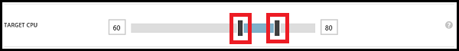

1. You can specify the number of instances to add or turn on each time your application is scaled up. To increase the number of instances that are created or turned on when your application is scaled up, drag the bar right. To decrease the number, drag the bar left.



1. Set the number of minutes to wait between the last scaling action and the next scale-up action. The last scaling action can be either scale-up or scale-down.

Up time

All instances are included when calculating the average percentage of CPU usage and the average is based on use over the previous hour. Depending on the number of instances that your application is using, it can take longer than the specified wait time for the scale action to occur if the wait time is set very low. The minimum time between scaling actions is five minutes. Scaling actions cannot occur if any of the instances are in a transitioning state.

1. You can also specify the number of instances to delete or turn off when your application is scaled down. To increase the number of instances that are deleted or turned off when your application is scaled down, drag the bar right. To decrease the number, drag the bar left.



If your application can have sudden increases in CPU usage, you must make sure that you have a sufficient minimum number of instances to handle them.

1. Set the number of minutes to wait between the last scaling action and the next scale-down action. The last scaling action can be either scale-up or scale-down.

Down time

1. Click **Save**. The scaling action can take up to five minutes to finish.

## Summary

In this hands-on Lab, you have learnt how to deploy a simple PHP Web application to a Web server hosted in Microsoft Azure, using MySQL and configuring load balancing. Finally, you automated the deployment with PowerShell and enabled auto scaling for the application.